One (1) Time ACH Payment Authorization

Sign and complete this form to authorize ___________________________ to make a one (1) time debit to your checking or savings account.

By signing this form, you give us permission to debit your account for the amount indicated on or after the indicated date. This is permission for a single transaction only, and does not provide authorization for any additional unrelated debits or credits to your account.

I _______________________ authorize _________________________ to charge my
(Full Name) (Merchant’s Name)

bank account indicated below for $________________ on ________________.
(Amount $) (Date)

This payment is for ________________________________.
(Description of Goods/Services)

Billing Information

Billing Address ___________________________ Phone # ______________________

City, State, Zip ___________________________ Email ________________________

Bank Details

☐ Checking ☐ Savings

Account Name _________________________
Bank Name _________________________
Account Number _________________________
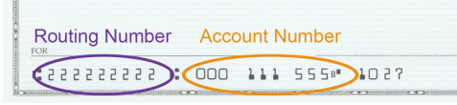
Routing Number _________________________

I understand that because this is an electronic transaction, these funds may be withdrawn from my account as soon as the above noted transaction date. In the case of the payment being rejected for Non-Sufficient Funds (NSF) I understand that ___________________________ may, at its discretion, attempt to process the charge again within 30 days, and I agree to an additional $______ charge for each attempt returned NSF, which will be initiated as a separate transaction from the authorized payment. I acknowledge that the origination of ACH transactions to my account must comply with the provisions of U.S. law. I will not dispute ___________________________ billing with my bank so long as the transaction corresponds to the terms indicated in this agreement.

SIGNATURE ___________________________ DATE _____________________
(Account Holder’s Signature)

