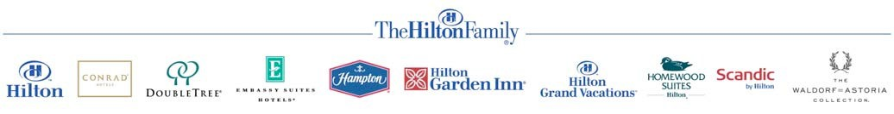

Credit Card Payment Authorization Form

Do not send completed form by email.

FAX COMPLETED FORM TO:
ATTN:

Date:

HOTEL USE ONLY:
Guest / Group Name: Check-In / Event Date:
Name of Person/Group Making Reservation: Phone:
Authorized Amount: Approval Code: Date:

CARDHOLDER - Please complete the following section and sign/date below.
Cardholder Name as it Appears on Credit Card: Cardholder Billing Address:
City: State: Zip:
Daytime /Business Telephone: Evening Telephone: Credit Card Number: Expiration Date: Credit Card Type: (Check one) ☐ Visa ☐ MasterCard
☐ American Express ☐ Discover ☐ JCB ☐ Diners Club
Credit Card Issuing Bank Name: _____________ Bank Security Number (from back of your credit card): _______________________

I agree to cover the following categories of charges: (Please check)
☐ All Charges ☐ Room & Tax ☐ Food & Beverage ☐ Retail ☐ Recreation

I agree to cover the above categories of charges up to a Maximum Amount of $

Note: Charges for room and tax, group deposits or direct bill account payments will be charged to your credit card immediately. Any incidental charges circled above will be charged at the time of check-out.

Amount to be immediately charged to credit card for room and taxes or deposit: $

Final Balance Billed to Credit Card (hotel use only): $

By signing below, you authorize the hotel to charge your credit card immediately for the amount indicated above up to the “Maximum Amount” indicated above. You further acknowledge that if “all charges” has been selected, then all guest/group related charges (less Deposit) will be charged to the above card number at the time of checkout or event conclusion.

Cardholder Signature: Date:

