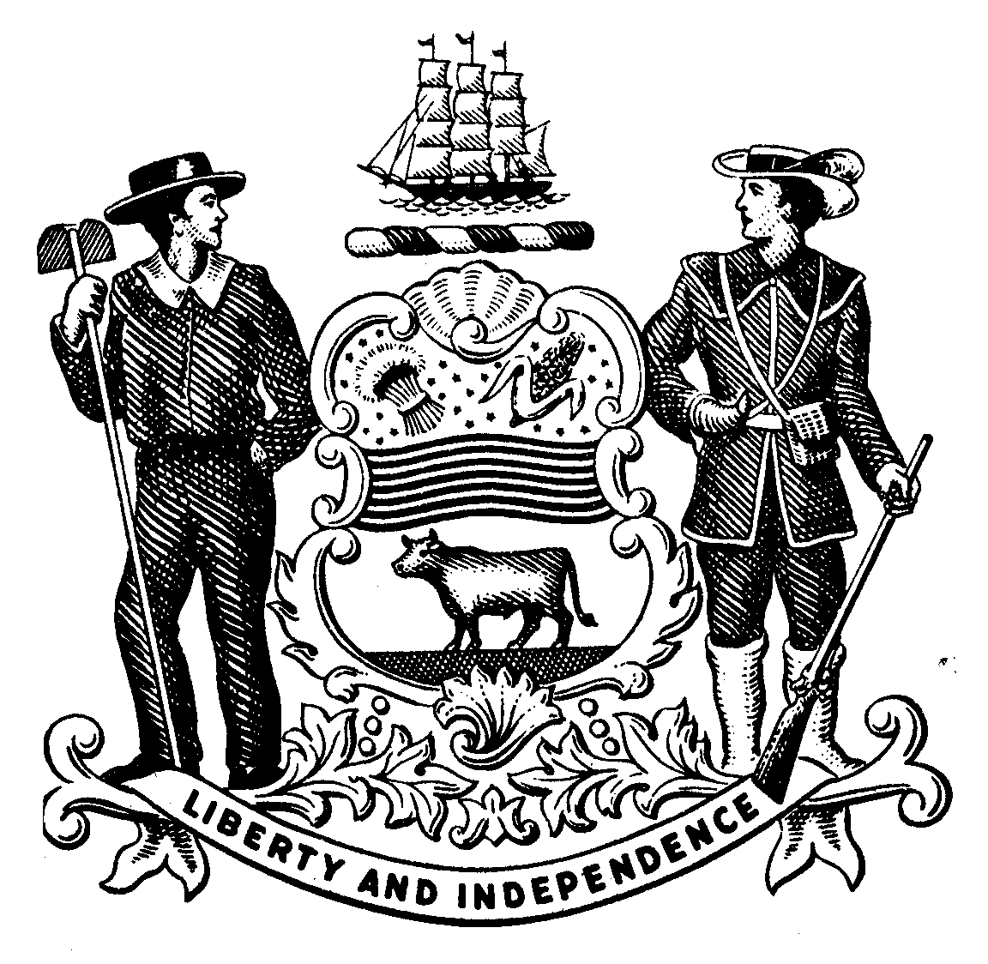

STATE OF DELAWARE DEPARTMENT OF TRANSPORTATION
DIVISION OF MOTOR VEHICLES
www.dmv.de.gov

POWER OF ATTORNEY TO CONDUCT MOTOR VEHICLE BUSINESS

To the Delaware Division of Motor Vehicles and to whom it may concern:

I, the undersigned of

(address), City of

, County of , State of

, appoint , of

(address), City of _,

County of _, State of , as my attorney in fact to sign all papers and documents that may be necessary in order to conduct motor vehicle business for the following described vehicle:
, _, _.
Make of Vehicle Model Year Vehicle Identification Number

I agree to indemnify and hold harmless the State of Delaware and all public officials from the Delaware Division of Motor Vehicles from any and all liability that may accrue from motor vehicle work for the so described vehicle.

Date Signature of Owner

State of Delaware
Signature of Co-Owner

County

Be it remembered that on this day of , A.D. , the Subscriber personally came before me.

Notary Public

Form MV386 (Revised 03/12)

