Notice of Revocation of Power of Attorney

I, (name) [NAME], of the City of [CITY], County of [COUNTY], State of California, revoke the power of attorney dated [DATED], empowering (name(s)) [NAME(S)], to act as my agent. I revoke and withdraw all power and authority granted under that power of attorney.

Dated: [Date]

Signature of Principal

Principal

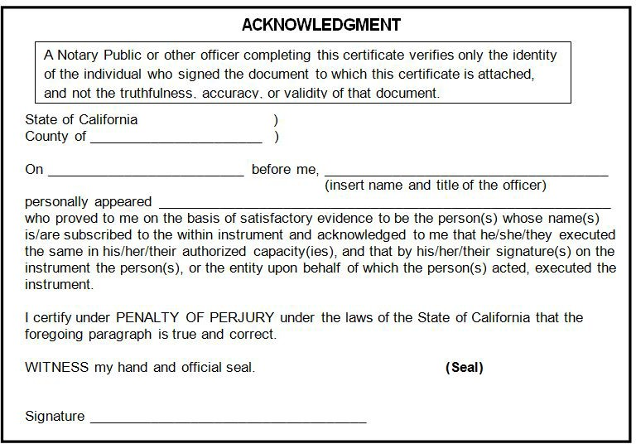

Form Made Fillable by [eForms](https://eforms.com/)