SAMPLE ACTION ITEMS MEETING MINUTES FOR JONES CONSULTANTS, INC.

MEETING DETAILS

Chairperson: Caroline Vogel (Project Manager) Secretary: Andrew Cruz

Date: February 9, 2021
Time: 11:00 am

Location: Jones Consultants’ Headquarters Street Address: 1234 Main St.
City: Los Angeles State: CA Zip: 91111

ATTENDEES.

  - Caroline Vogel (Project Manager)
  - Andrew Cruz (Secretary)
  - Amanda Sanders (Designer)
  - Eva Montell (Project Coordinator)

ABSENCES.

  - Trevor Marcille (Legal)

CALL TO ORDER.

Previous Meeting Minutes – Speaker Caroline Vogel – 11:01 am
The Chairperson called the meeting to order to approve the minutes from the February 8, 2021 meeting. Meeting attendees voted unanimously to approve the minutes.

Current Meeting Agenda – Speaker Caroline Vogel – 11:04 am
Andrew distributed the current meeting agenda to all attendees to review for questions and additions.

At 11:06 am, the attendees voted unanimously to approve the agenda.

OLD BUSINESS. Old Business
Since this was the first action items meeting regarding this project, there was no old business to discuss.

NEW BUSINESS.

New Action Items and Assignments – Speaker Caroline Vogel – 11:07 am
  - Concept
    - Caroline Vogel and Amanda Sanders
    - Due: March 19, 2021

  - Draft plan
    - Amanda Sanders
    - Due March 19, 2021
  - Schedule three site visits
    - Amanda Sanders
    - Due: February 19, 2021
  - Keep up with agreed reporting and scheduling
    - Amanda Sanders
    - Due: Ongoing
  - Complete Zoning and Code Report
    - Trevor Marcille
    - Due: March 12, 2021

ADJOURNEMENT

Adjournment – Speaker Caroline Vogel – 11:27 am
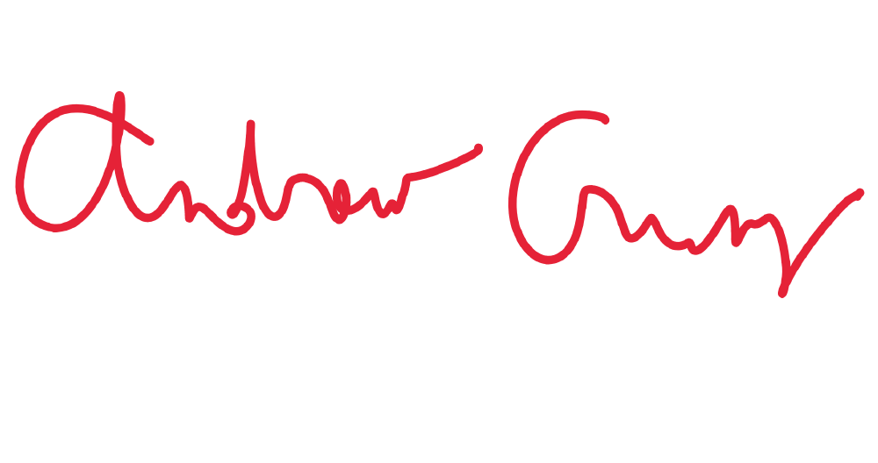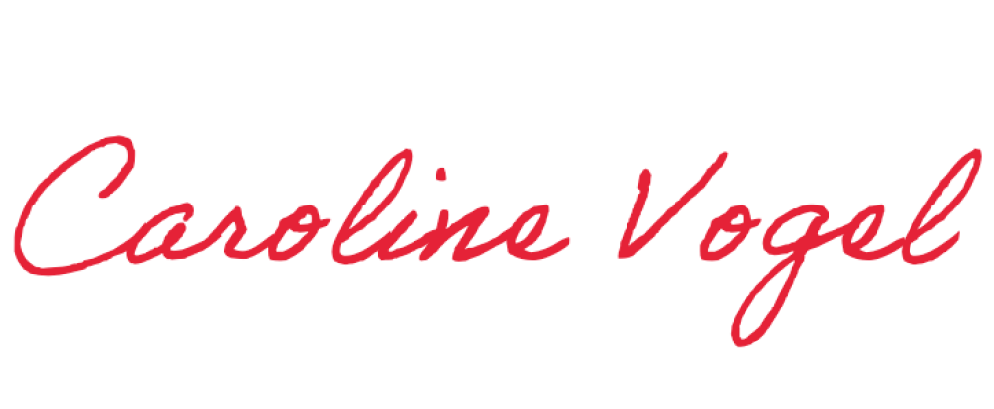Caroline called an end to the meeting. Andrew recorded the end time and Caroline approved the minutes.

Minutes submitted by: Print Name: _Andrew Cruz _ Approved by: Print Name: _Caroline Vogel

