SAMPLE ANNUAL MEETING MINUTES FOR PACIFIC COAST PHILHARMONIC

MEETING DETAILS

Chairperson: Jasmine Brown (Board Chair) Secretary: Deborah Walker (Secretary)

Date: December 4, 2020
Time: 11:00 am

Location: Williams Hall Admin Offices Street Address: 1359 Sur Road
City: Thatcher
State: CA Zip: 92485

ATTENDEES

  - Jasmine Brown (Board Chair)
  - Deborah Walker (Board Secretary)
  - Ron Clark (Fundraising Chair)
  - Sarah Finley (Finance Chair)
  - Chris Noah (Programming Chair)
  - Eli Gordon (Legal Council)
  - Kate Padilla (Chief Executive Officer)
  - Michelle Hudson (Chief Finance Officer)
  - Sandra Rennie (Chief Operating Officer)

ABSENCES

  - No absentees.

CALL TO ORDER

Welcome – Speaker Jasmine Brown (Board Chair) – 11:00 am Jasmine welcomed everyone and reviewed the meeting goals:
  - Summarize the successes, failures, and lessons learned in the past year;
  - Review what the next twelve months will look like for the organization; and
  - Elect a new Board Chair for 2021.

Previous Meeting Minutes – Speaker Deborah Walker (Board Secretary) – 11:04 Deborah distributed the meeting minutes from the December 6, 2019 annual meeting. The attendees had a chance to review the minutes for accuracy, then Deborah put the minutes to a vote. The attendees unanimously voted to approve the minutes.

Current Meeting Agenda – Speaker Deborah Walker – 11:11 am
Then Deborah distributed the current meeting’s agenda which everyone also had a chance to review. Deborah gave the attendees a chance to request additions or changes, but there were none. She led the group in a unanimous vote to approve the agenda.

OLD BUSINESS

Summary of Past Year – Speaker Kate Padilla (CEO) – 11:19 am
Kate moderated a discussion about the successes, failures, fiscal performance, growth, and staff turnover for 2020.

NEW BUSINESS

Upcoming Projects – Speaker Sandra Rennie (COO) – 11:30 am
Sandra presented specifics and status reports about all of the major projects that the Philharmonic will participate in in 2021.

Budget Review – Speaker Michelle Hudson (CFO) – 11:40 am
Michelle presented an overview of the 2021 budget and answered many questions.

VOTE

Board of Directors Election – Speaker Jasmine Brown – 11:50am
Jasmine led the Board in a vote for the 2021 Board Chair. This person will replace Jasmine as she retires at the end of 2020. The Board elected Cori Czeresko, long-time friend of the Philharmonic.

ADJOURNMENT

End of Meeting – Speaker Jasmine Brown – 12:00 pm
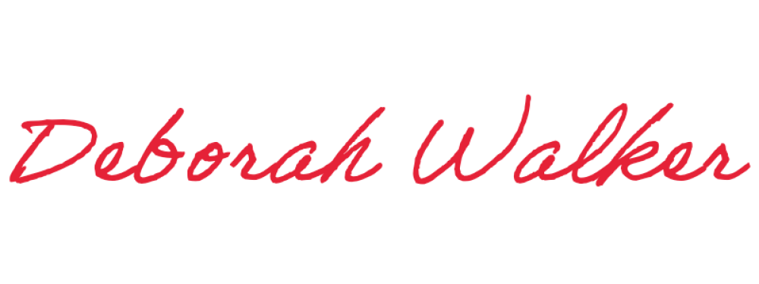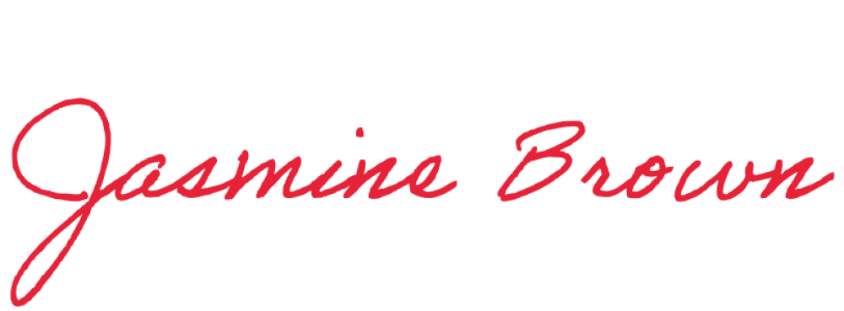Jasmine called an end to the meeting at 12:00 pm. Deborah recorded the end time and Jasmine approved the minutes.

Minutes submitted by: Print Name: _Deborah Walke_r

Approved by: Print Name: _Jasmine Brown

