SAMPLE BUSINESS MEETING MINUTES FOR JONES CONSULTANTS, INC.

MEETING DETAILS

Chairperson: Kathleen Jones Secretary: Andrew Cruz

Date: January 11, 2021
Time: 10:00 am

Location: Jones Consultants’ Headquarters Street Address: 1234 Main St.
City: Los Angeles State: CA Zip: 91111

ATTENDEES.

  - Kathleen Jones
  - Andrew Cruz
  - Jane Richardson
  - Matthew Johnson
  - Caroline Vogel
  - Brady Foster

ABSENCES.

  - Jeffrey Bowler
  - Sarah Andrews
  - Clayton Pelch

CALL TO ORDER.

Previous Meeting Minutes - Speaker Kathleen Jones - 10:05 am

There was a call to order by the Chairperson to approve the meeting minutes from the January 4, 2021 meeting. Attendees voted unanimously to approve the minutes.

Current Meeting Agenda - Speaker Kathleen Jones - 10:15 am

The meeting agenda was distributed to all attendees, who were given time to review for any questions or additions.

At 10:23 am, the attendees voted unanimously to approve the agenda without any additions.

OLD BUSINESS.

Search for New Office Manager - Speaker Jane Richardson - 10:24 am

As mentioned in last week’s meeting, interviews have begun for the open position of Office Manager. Any new applicants will be kept on hold until the first round of interviews has been completed.

First Quarter Goal Setting - Speaker Matthew Johnson - 10:30 am

As mentioned in last week’s meeting, all employees must schedule a one-on-one meeting with their supervisor to discuss their goals for the first quarter of 2021. These meetings must be completed no later than January 22, 2021.

NEW BUSINESS.

New Client - Speaker Caroline Vogel - 10:42 am

As of the new year, Caroline has secured a new business client, Art Promotions, LLC., based in San Diego, CA. Their main goal is to develop a new space plan for company headquarters that is more in line with the current company culture. Caroline will travel to San Diego from January 19-29, 2021, to begin space planning with Art Promotions, LLC. executives.

OTHER ITEMS.

2021 Holiday Schedule - Speaker Kathleen Jones - 10:55 am The paid holiday schedule for 2021 will be:
  - New Year’s Day, January 1, 2021
  - Martin Luther King, Jr. Day, January 18, 2021
  - Easter, April 4, 2021
  - Memorial Day, May 31, 2021
  - Independence Day, July 4, 2021
  - Labor Day, September 6, 2021
  - Indigenous Peoples’ Day, October 11, 2021
  - Thanksgiving, November 25-26, 2021
  - Christmas, December 24-25, 2021
  - New Year’s Eve, December 31, 2021

ADJOURNMENT.

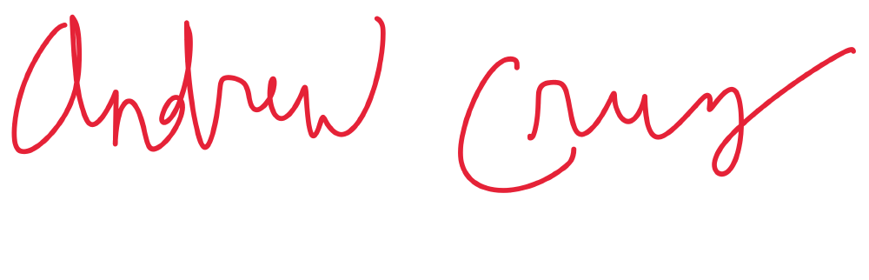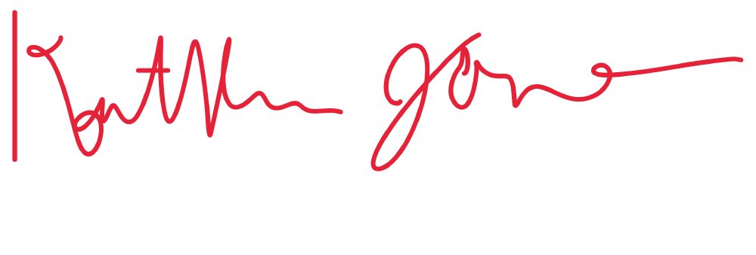End of Meeting - Speaker Kathleen Jones - 11:00 am

Minutes submitted by: Print Name: Andrew Cruz Approved by: Print Name: Kathleen Jones

