SAMPLE CORPORATE MEETING MINUTES FOR ART PROMOTIONS, LLC.

MEETING DETAILS

Chairperson: Kate Bansagi Secretary: Adrianne Charlot

Date: February 12, 2021
Time: 10:00 am

Location: Art Promotions, LLC. Street Address: 5784 Spring St. City: Los Angeles
State: CA Zip: 97858

ATTENDEES

  - Tyra Hudson (CEO)
  - Kate Bansagi (Director of Business Development)
  - Dora Cyrus (Facilities Manager)
  - Tim Jones (HR Director)
  - Daryl Curry (Finance Director)
  - Adrianne Charlot (Secretary)

ABSENCES

  - No absences

CALL TO ORDER

Introduction – Speaker Kate Bansagi – 10:00 am
Kate welcomed everyone to the meeting and outlined the meeting goals.

Previous Meeting Minutes – Speaker Kate Bansagi – 10:05 am
Adrianne distributed the previous meeting minutes for all to review. Kate led everyone in a vote to approve the minutes. The group unanimously voted to approve.

Current Meeting Agenda – Speaker Kate Bansagi – 10:09 am
Adrianne distributed the current meeting agenda for all to review. Kate led everyone in a vote to approve the agenda. The group unanimously voted to approve.

OLD BUSINESS

Old Business – Speaker Kate Bansagi – 10:13 am
There was no outstanding business to address in this meeting.

NEW BUSINESS

Space Planning – Speaker Kate Bansagi – 10:14 am

Kate presented the full proposal and schedule from Jones Consultants, Inc. for the new space planning project.

VOTE

Jones Consultants – Speaker Kate Bansagi – 10:24 am
Kate led a vote to finalize the decision to contract with Jones Consultants for the space planning project. The group voted unanimously to sign the contract.

ADJOURNMENT

Next Meeting – Speaker Kate Bansagi – 10:29 am
Kate scheduled the next corporate meeting on February 26, 2021.

End of Meeting – Speaker Kate Bansagi – 10:30 am Kate called a formal end to the meeting.

Approval of Minutes – Speaker Adrianne Charlot – 10:30 am
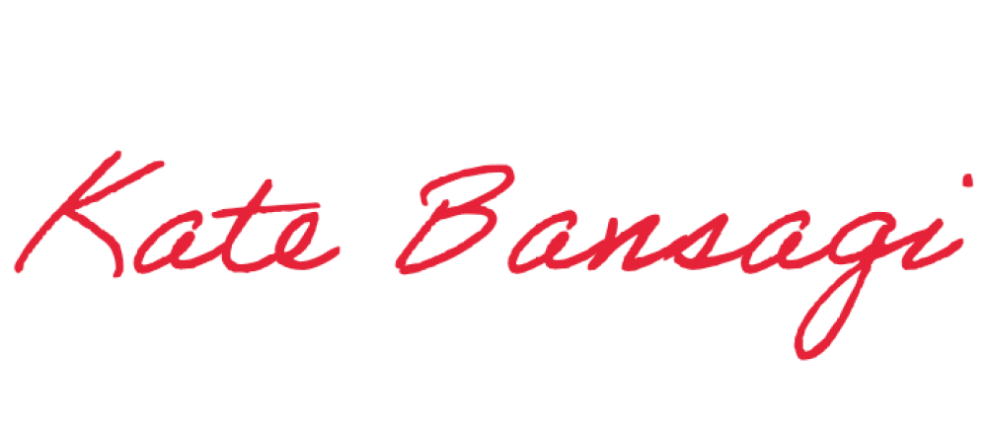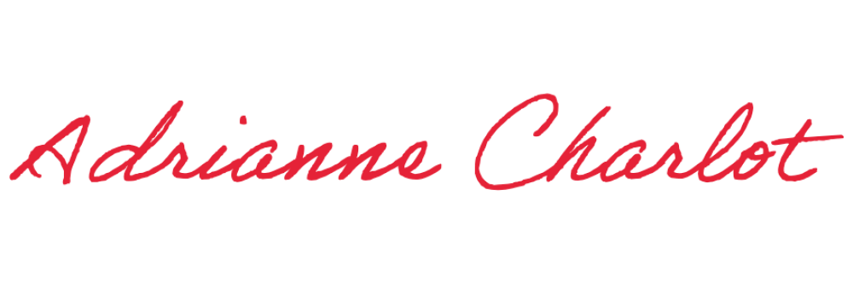Adrianne recorded the end time and Kate approved the meeting minutes.

Minutes submitted by: Print Name: _Adrianne Charlo_t

Approved by: Print Name: _Kate Bansagi

