SAMPLE COUNCIL MEETING MINUTES FOR CITY OF SHADY OAKS, CA

MEETING DETAILS

Chairperson: Mayor Ana Carratelli Secretary: Sebastian Plachy

Date: March 5, 2021
Time: 11:00 am

Location: Shady Oaks City Hall Street Address: 57389 Autumn Rd. City: Shady Oaks
State: CA Zip: 91284

ATTENDANCE

  - Mayor Ana Carratelli (Council Chair) – PRESENT
  - Chloe May (Council President) – PRESENT
  - Sebastian Plachy (Secretary) – PRESENT
  - Amanda Ettinger (Council Member) – PRESENT
  - Antonio Voci (Council Member) – PRESENT
  - Diana Campa (Council Member) – PRESENT
  - Scott Michael (Council Member) – PRESENT
  - Wendy Toledo (Council Member) – PRESENT
  - Adriana Molter (Council Member) – PRESENT
  - Fiona Alpert (Council Member) – PRESENT
  - Hailey Jordan (Council Member) – PRESENT
  - Natalia Leary (Council Member) – ABSENT

CALL TO ORDER

Previous Meeting Minutes – Speaker Mayor Ana Carratelli – 11:02 am
Mr. Plachy passed out copies of the previous meeting minutes for all to review. The council voted unanimously to approve the minutes in a vote led by Mayor Carratelli.

Current Meeting Agenda – Speaker Mayor Ana Carratelli – 11:07 am
Mr. Plachy passed out copies of the current meeting agenda for all to review. The council voted unanimously to approve the agendain a vote led by Mayor Carratelli.

OLD BUSINESS

Pothole on Glennview Ave. – Speaker Amanda Ettinger – 11:12 am
Ms. Ettinger updated the council on the repair of the large pothole on Glennview Ave. that is blocking the main entrance to the high school parking lot. The repairs should be done by March 14th.

NEW BUSINESS
Memorial Day Parade – Speaker Fiona Alpert – 11:18 am
Ms. Alpert presented the plan for implementing the annual Memorial Day parade and celebration at the Community Center.

OTHER ITEMS

Other Items – There were no other items for this meeting.

PUBLIC COMMENT

Shady Oaks Recreation Center – Speaker Oliver Rodgers – 11:29 am
Resident Mr. Rodgers pressed the council for an update about the reopening of the rec center. The council said it would put together an update presentation for the next council meeting.

ADJOURNMENT

End of Meeting – Speaker Mayor Ana Carratelli – 11:38 am
Mayor Carratelli called an end to the meeting and Mr. Plachy recorded the end time.

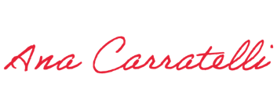
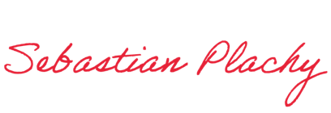
Approval of Minutes – Speaker Mayor Ana Carratelli – 11:39 am Mayor Carratelli approved the minutes.
Minutes submitted by: Print Name: _Sebastian Plachy _

Approved by: Print Name: _Mayor Ana Carratelli

