SAMPLE FIRST-TIME MEETING MINUTES FOR ANDREW CRUZ

MEETING DETAILS

Supervisor: Kathleen Jones New Employee: Andrew Cruz

Date: January 12, 2021
Time: 11:00 am

Location: Jones Consultants’ Headquarters Street Address: 1234 Main St.
City: Los Angeles State: CA Zip: 91111

INTRODUCTION

  - Kathleen welcomed Andrew to Jones Consultants and reviewed his job description.
  - Kathleen also shared her background and experience starting and running the business

PERSONAL BACKGROUND

  - Grew up in Seattle, WA;
  - Has a B.A. in Communications from UCLA (2020);
  - Lives with two roommates in West Hollywood; and
  - Hobbies include surfing, bike riding, reading, and hanging out with his dog.

COMMUNICATION

  - Prefers email communication whenever possible, call or text if the matter is urgent

AVAILABILITY

  - Available Monday through Friday 8:30am – 4:30pm and anytime on Saturdays

GOALS AND ASPIRATIONS

  - He would like to pursue a career in Industrial & Organizational Psychology
  - Sees this position as a good first job post-Bachelor’s to enter the world of office management and HR

TYPES OF WORK

  - Has great communication and organizational skills
  - Will have him manage all general office communications and manage all office supplies and mail

FREQUENCY

  - 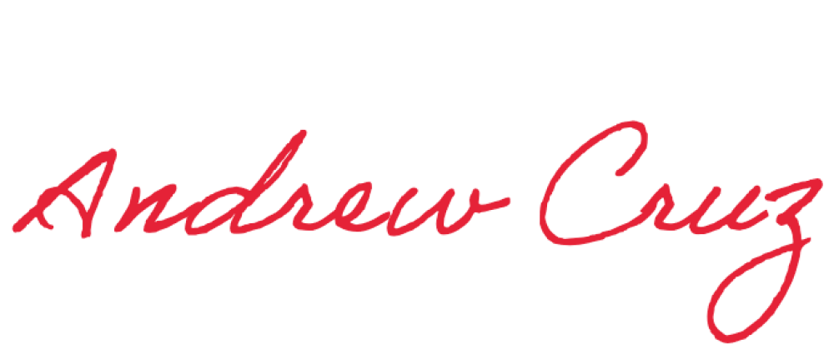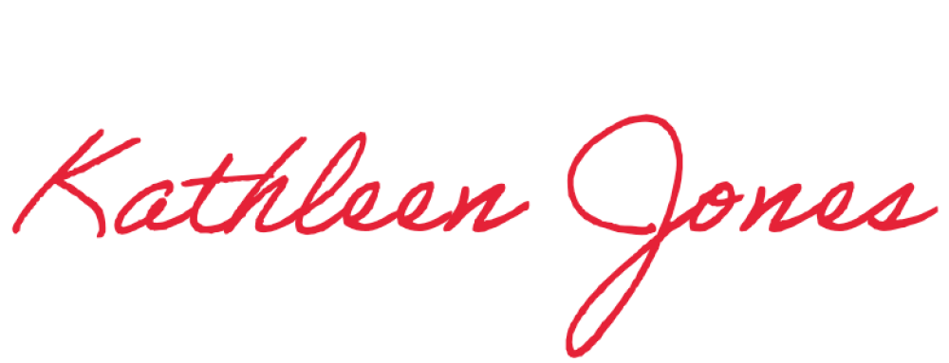Bi-monthly one-on-one meetings

Minutes submitted by: Print Name:

Kathleen Jones
_

Approved by: Print Name:
Andrew Cruz

